Suzuki Jimny Analysis and Price Prediction
Planning a project to predict the prices of Suzuki Jimnys

The Suzuki Jimny is a nifty little off-roader produced in various forms by Suzuki since 1985. Its compact size and 4x4 capabilities make it a firm favourite among off-road enthusiasts and has earned it a cult following. There are subreddits, owners groups and in-person meet-ups dedicated to celebrating this adorable feat of engineering and although this community is spread across the world, there are hotspots of Jimny-lovers in South Africa, Japan and New Zealand.

Fig1 - AI-generated image
I like to describe it as the product of a monster truck and a golf buggy.
This project aims to investigate the factors that affect the price and create a predictive model that can predict the price of a Jimny. It will use data scraped from car sales websites such as Autotrader. Comparing data from Samurais (The precursor to the Jimny) will require different data sources as this is a more of a collectors car so is not listed on regular second-hand car sites.
Gathering data from different sources and compiling them together will be the biggest bulk of the work. Using data from different websites means I could have different columns from each source which would result in lots of null values. I could also have issues with duplicates if a car is listed on multiple sites. However, these problems can be accounted for and it is extremely important to have a large dataset to facilitate a train/test split and improve accuracy, I will aim for 1000 entries in my dataset.
I will briefly look into the evolution of the car. This background knowledge will help justify some decisions made later – and it’s super interesting.
This prediction will be made based on the year, milage and engine transmission. An extension will be to include the MOT data and create a score for this that will be used in the prediction.
With the end product, we will be able to input the details from an existing listing and compare the predicted price with the actual price to see if the car is a good deal for it’s condition. This will be done using the interactive sliders and input function on Streamlit.
How will this project be used?
This project can be used in the very real use case of my needing to buy a car. It can be used to assess the available options to see if they are good value cars by comparing the predicted price with the real price.
The user will be able to interact with a Streamlit app to input the values for the car and the price will change based on the inputted values. This will be demonstrated with cars found on Auto-trader, Ebay and other sites.
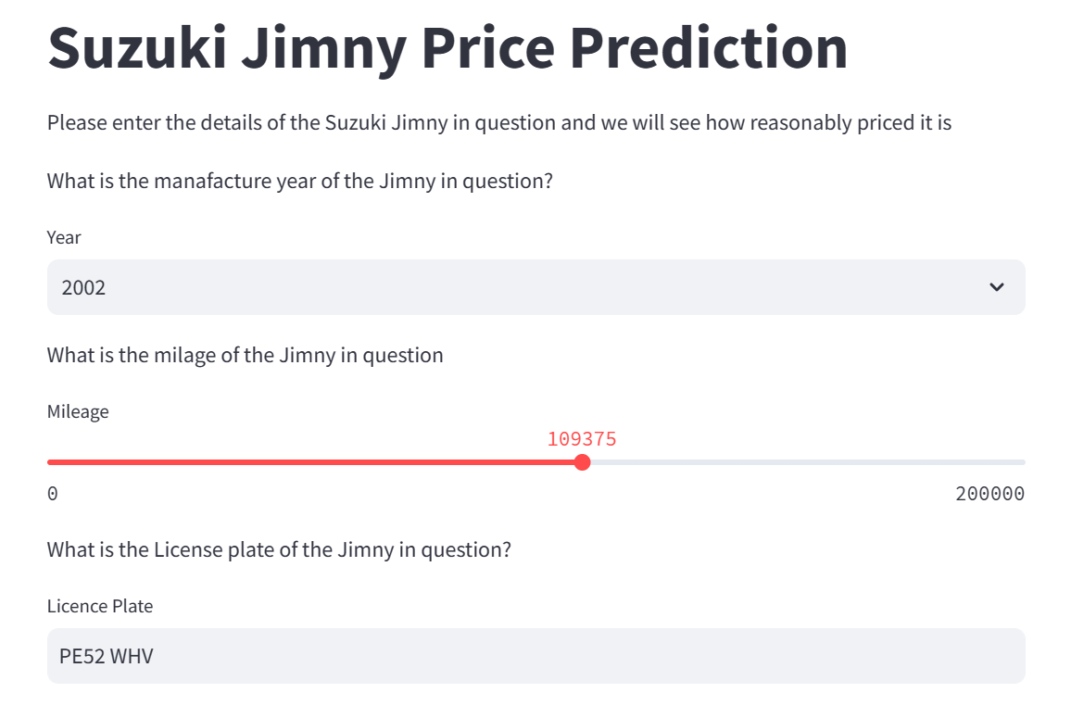
Fig 2 - Image of the streamlit app (first draft) with inputs.

What are the current solutions available?

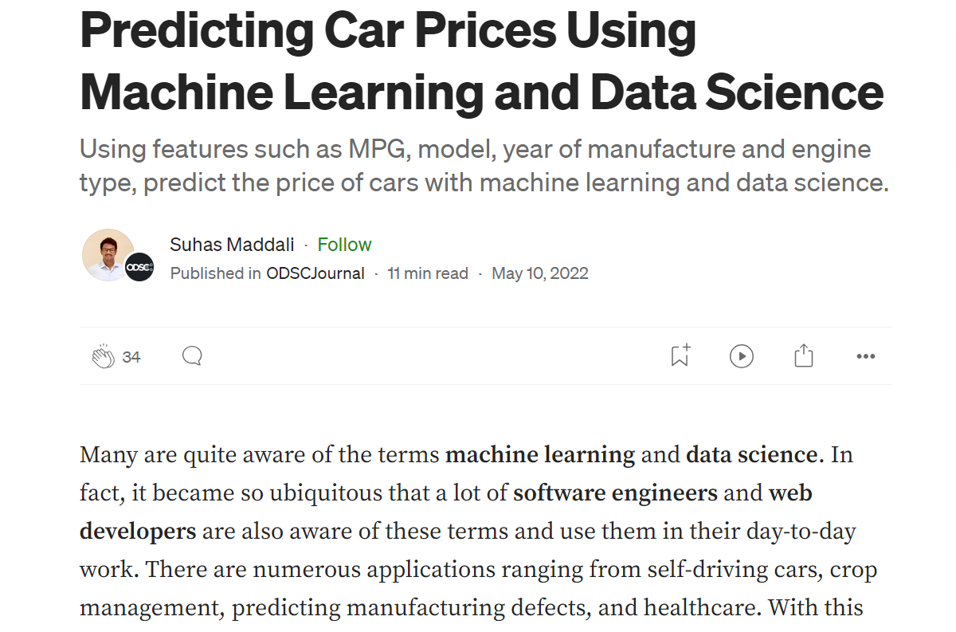
Fig 3 - Medium project predicting car prices
https://medium.com/odscjournal/predicting-car-prices-using-machine-learning-and-data-science-52ed44abab1b

There is another machine learning (ML) project predicting the price of cars on Medium. This one has similarities to my project; it is predicting the price of cars – and the main difference is in that mine is specifically looking at Jimnys. This project tries a variety of different model types – Linear regression, GXBoost and Decision Trees and compares the actual and predicted values to decide which model to use. This is something I can incorporate in my project.
The are many different car price analysis tools available. Most of them are paid products aimed at car dealers as opposed to individual buyers. They also seem to be very regional, with most searches requiring the user to input “City” or “State” from a predefined list limited to just one country. My solution will also be limited to one country – the UK.

It seems that the main metrics existing tools use, is mileage and year of manufacture, so I could improve upon these by including MOT information. MOT history checks are publicly available on the government website if you have the car’s license plate.
License plates are not included in the car listing, but are in photos. We can use computer vision to extract the car’s license plate and input this into the government website to retrieve the MOT history.
How should I frame this problem?
This project will start with storytelling, explaining the history of the car and observing some trends in the dataset. This background information will help explain why I have chosen to zoom in on this specific car instead of working with more general data set.
Then it’ll move into supervised ML modelling where price will be the target variable and a price will be predicted based on a list of metrics such as mileage and year of manufacture.
There will also be an element of computer vision; The license plate will be extracted from images of the car and used to retrieve the MOT history from the government website. This will be used to produce a score for the car, giving the users an idea as to it’s condition. This score will be used in the prediction.
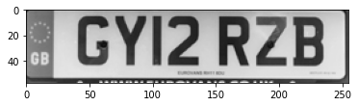
Fig 3 - Computer vision for license plate recognition
https://medium.com/augmented-startups/automatic-number-plate-recognition-with-easy-ocr-and-open-cv-6d121384cdc7

How should performance be measured?
Performance will be measured by the accuracy of the model, which will be measured by the Root Mean Squared Error (RMSE). This value will be evaluated on unseen, test data.
There isn’t available information about the existing solutions so I will set my own benchmark, that predicted prices being within £500 of the real price is a case for success. I have chosen the value of £500 because any larger of an error would cause users to distrust the system.
Is the performance measure aligned with the objective?
The accuracy metric of RMSE is aligned with my objective. It reflects the difference between the predicted and real price which is the most important metric to the user. As the purpose of the project is to predict the price of Jimnys, this needs to be done accurately.
The RMSE of £500 is based on my general understanding that £7500 is about average for a Jimny and that makes £500 around 7% of the average price. I would be happy with an error of 10% but want to set a challenge so have lowered that to 7%. I believe if the predicted values are more than £500 away from the actual price, the usefulness will begin to fade and users would lose faith in the model.
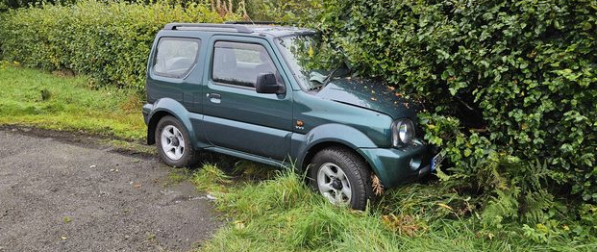
Fig 4 - If our RMSE is more than £500 it would be a car crash
https://www.reddit.com/r/CarTalkUK/comments/177lm7l/lost_control_of_my_2005_suzuki_jimny_in_wet/

What would be the minimum performance needed to reach the objective?
The minimum performance for this project would be an interactive dashboard that tells the user a bit about the evolution of the car and takes inputs to predict the price of the car. The input function will take details such as mileage and year to return the price. It will be within £500 of the actual price on unseen data. It will be able to answer the question; Is this Jimny reasonably priced?
Is human expertise available?
Yes, I have plenty of experience browsing the internet looking at cars and have learnt a lot about what factors influence the price of the vehicle. For example, what areas of the car are particularly prone to rust and how this information can be found through the MOT history check, which is publicly available from the Government website.
My expertise allows me to see the limitations of just using mileage and year data. Certain features give details about what quality the car could be in. For example, if the car has a snorkel, it must have been used off-road and this usage can cause faster deterioration to the chassis of the car. Additionally, there are soft-top convertible Jimnys which are more desired but less functional because they have bigger insurance premiums and the roof is prone to leaking, causing rust on the seams of the roof.
An area where I do not have expertise is in the MOT history. I may require additional guidance to know how to create the score. For example, which advisories pose a risk to the lifespan of the vehicle and what red flags to look out for. I can use online forums for this purpose but ideally it would be useful to find a mechanic who can advise me.
What are the rough steps to approach this project?
Step 1: Decide on data sources. Available options include AutoTrader, Ebay, Facebook Marketplace. I would like to find sources that have similar details available to limit the amount of nulls in my dataset. I want to avoid imputing values as 1000 is already a small dataset.
Step 2: Gather data from sources. I will use web scraping to extract the data into one CSV.
Step 3: Clean the data. This will include deleting duplicates, putting all of the columns into the desired data types and dealing with missing values. These first three steps are going to take up most of my time.
Step 4: Exploratory data analysis (EDA). This will involve visualising trends in the dataset, Identifying any outliers and identifying strong correlations in our data.
Step 5: Train-test split
Step 6: Initial models – Similar to the Medium project mentioned above, I will try out a range of different models and continue with the one that has the most accurate initial predictions and optimizations.
Step 7: Optimize the model. Using GridSearch and error analysis I will improve the accuracy of the model until it reaches our benchmark.
Step 8: Build the interactive interface
Step 9: Test, test and test some more
List the assumptions you (or others) have made so far.
I am assuming that there is a decent quantity of data available for the project and that the sites I have chosen can be scraped from. As there are multiple data sources available, if this assumption turns out to be false I can change my data sources.
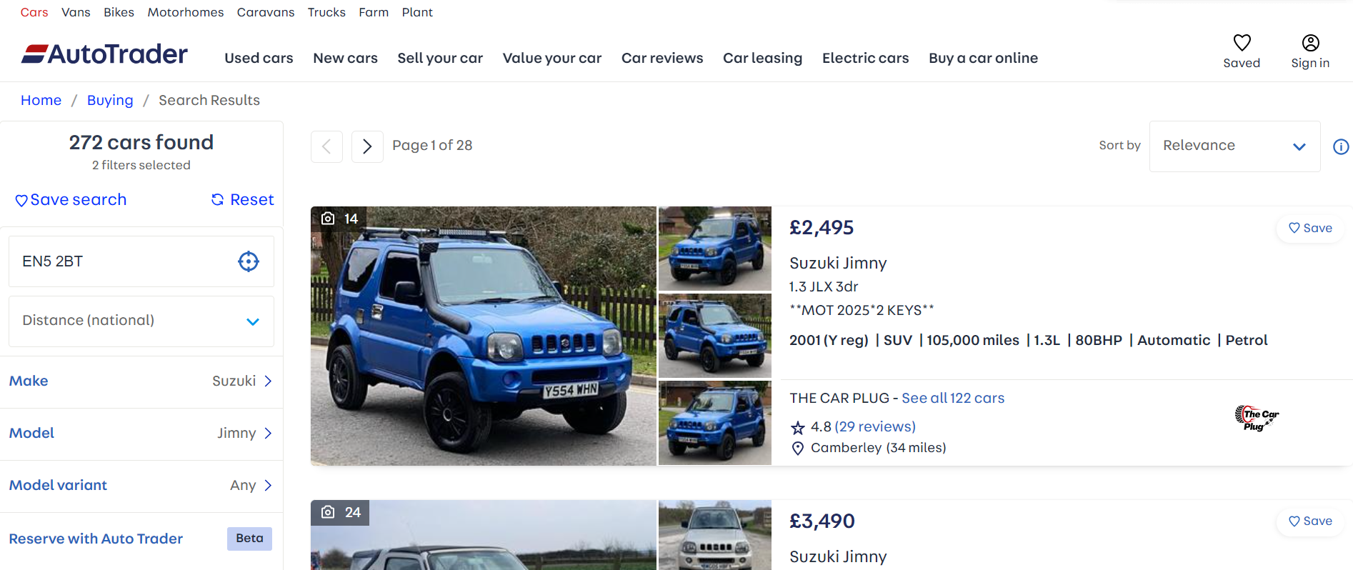
Fig 5 - AutoTrader will our main source of data. We are assuming that it can be web scraped
https://www.autotrader.co.uk/

I am assuming that the images listed on the site, will have the license plate clear and visible for computer vision. This could be false in some cases as some sellers purposely try to obscure the license plate in their images. Different camera angles could pose a challenge when recognising number plates.
I am assuming that the government MOT check portal will allow me to web scrape from multiple URLs in a short space of time.
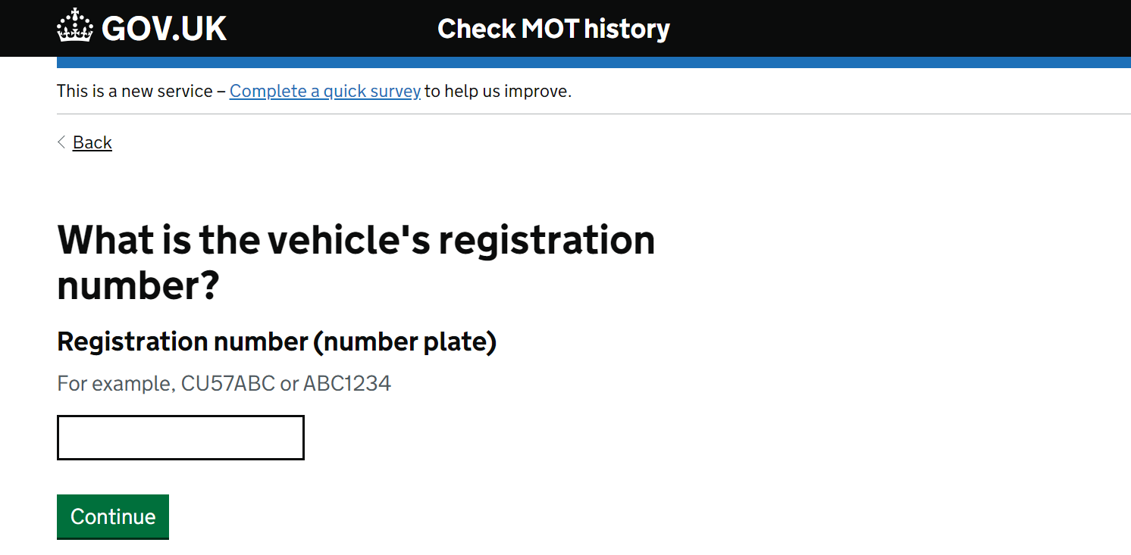
Fig 6 – The Government MOT history check portal
https://www.check-mot.service.gov.uk/

